**DNA structure:**3.2 billion **base pairs**碱基对.The **structure of DNA** is a double helix. **Deoxyribonucleic acid脱氧核糖核苷酸** is found in the nucleus(细胞核), chloroplasts(叶绿体), and mitochondria(线粒体) of eukaryotes(真核生物).**Molecule** that carries the information for the growth, development, functioning and reproduction of all known living organisms (and viruses).**Nucleotides**核苷酸:Thymine胸腺嘧啶-Adenine腺嘌呤 and Guanine鸟嘌呤-Cytosine胞嘧啶**Antiparallel**反平行because one strand runs in the 5′(contains phosphate group 磷酸基团)→3′ (hydroxyl group 羟基)direction and the other runs in the 3′→5′ direction. **Composed of nucleotides**: a sugar molecule (deoxyribose核糖 in DNA脱氧核糖, ribose in RNA), a phosphate group, and a nitrogen-containing base. **Why DNA Sequencing?** ①Comparative Genomics (Sequencing of many animal species/Structure and function of the human genome. /Genome evolution)②Human Genetic Variation (Genomic contribution to disease)③Agricultural important species④Microbial Communities (Medical/ Environmental/ Food/ Bioterrorism) **Polymerase Chain Reaction (PCR) 聚合酶链反应** (amplify a DNA sample)PCR COVID testing relies on 3 set of primers targeting 3 different regions of the SARS-COV-2 genome.**1 PCR Preparation准备阶段①Primers引物**: **1.** primers will bind at a specific DNA sequence and mark the beginning of the DNA amplification. They define the length of the PCR product by limiting the sides of it. **2.** Primers are short fragments of DNA or RNA used to start DNA synthesis by a DNA polymerase. **Nucleotides:** nucleotides are required to build the new DNA sequence; they are the DNA building blocks. **DNA polymerase**: DNA polymerases are enzymes that are responsible for DNA synthesis (assembles the nucleotides based on the template sequence). Taq polymerase (most common DNA polymerase **DNA template:** 1. The basis of new DNA sequence amplification.2. Perform DNA isolation to extract DNA from cells. (First step) **Extra care with contaminations A thermocycler 2 PCR Experiment试验阶段**1. Denaturation Step (95 °C): At this high temperature, the hydrogen bonds holding together the two DNA strands are broken, and the DNA strands fall apart. The single-stranded DNA template is now available for copying.2.Annealing step(低温退火5-10 °C below the primer with lower Tm):short DNA pieces (primers) bind at complementary sites of the template DNA. The primers define the target sequence, which is the specific region of DNA that will be copied.3. Extension Step (72°C): An enzyme (DNA polymerase) is responsible for copying DNA. It recognizes the 3′ end of a primer bound to a template strand and starts copying the template DNA. It is a thermostable热稳定 polymerase (be active in the high temperature utilized).→DNA synthesis·The steps are repeated many times (often 30), producing billions of DNA copies of specific regions. **Gel electrophoresis凝胶电泳.①**To separate charged macromolecules (DNA, RNA, or proteins) of different sizes and to estimate their length. ②DNA (nucleic acids) is negatively charged, at neutral or basic pH in an aqueous environment, this technique is often used to separate DNA or RNA molecules.③The process is also useful to isolate and extract DNA fragments of a specific size.卡通人物

**Gel electrophoresis preparation准备阶段**1.Semi-solid, porous gel matrix. 2.Agarose琼脂糖 or polyacrylamide gel聚丙烯酰胺凝胶. 3. DNA or RNA sample 4. Loading buffer: To help visualize how far the DNA or RNA has traveled during gel electrophoresis. 5.Dye. 6. Molecular weight standard samples or "ladders" **Gel electrophoresis procedure程序阶段:** Smaller DNA molecules move faster through the gel than larger DNA molecules, leading to size separation. This difference in the rate of migration separates the fragments on the basis of size. **Gel electrophoresis analysis:** the different fragments are visualized as bands at specific distances from the top of the gel (the negative electrode end) on the basis of their size. The sizes of the nucleic acid samples can be estimated by comparing the distance with the molecular weight standard samples (also called DNA ladder).

**DNA ladder**

1. A mix of DNA or RNA fragments with known lengths. 2.Contains DNA of different lengths. The size of the fragments is determined by running a gel with the ladder in a well next to the samples with unknown lengths.

**Sequencing by Synthesis**

1. DNA is sheared into 200bp pieces

2. The sheared DNA is attached to the surface of a flow cell

3. The attached DNA is amplified via PCR

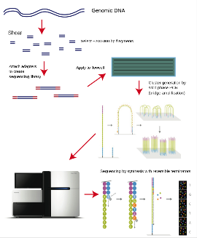4. Sequencing by synthesis using fluorescently labelled nucleotides

**Illumina:** the reversible dye termination technology

**Next Generation Sequencing**

Massively Parallel. /Higher throughput. /Lower cost. /Faster. /More accurate. /Although, Shorter read lengths

1.Sample preparation:

1) Fragmented (limit: length of DNA sample; max:250bp)-1. Sonication 2. Enzymatic

2) end-repair-To prevent DNA with these sticky ends from pairing with another DNA(Sticky ends to Blunt ends)

3) A-tailing (3’-A)

4)adapter ligation (function of adapter: primer and flow cell docker)

5) PCR amplification

2. Cluster generation: Bridge PCR and Flush

3. Sequencing process- by synthesizing each base pair.( Polymerase attachment\ Nucleotides tagged with fluorophore\ Fluorophore Detection\ Cleavage and removal)

**SNP Single Nucleotide Polymorphisms**

Rs6152 male baldness男性秃顶/ Rs1426654 light-skinned/ Rs17822931:allele C/C do not have blue eyes, instead they have brown eyes. A/A干耳 / Rs3827760：with hair thickness and tooth shape among Asians

**Third Generation Sequencing –** longer reads/ portable / speed

1. Nanopore Sequencing (Oxford Nanopores) / 2. SMRT sequencing (Pacific Biosciences)

**Unit 2**

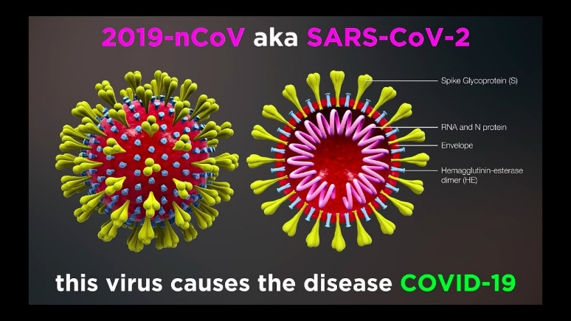**Detect proteins**： (The spike protein is a protein. /Antibodies are protein)→

**1ELISA** (enzyme-linked immunosorbent assay酶联免疫吸附测定) (high speed sensitivity and strong specificity)

·Uses antibodies抗体 and enzyme-mediated酶介导 color changes to detect the presence of either antigens抗原 (proteins蛋白质, peptides肽, hormones激素) or antibodies抗体(antibody-antigen reactions)

**Basic steps** of ELISA:  
1. Coating/capture: Immobilization固定 of the antibody or antigen to the surface of the microplate wells

2. Blocking: Addition of irrelevant protein or other molecules to cover all unsaturated不饱和 surface-binding sites of the microplate wells

3. Probing/detection: Incubation with the labeled antigen or antibody

4. Signal measurement: Detection of the signal generated via the labeled antigen or antibody

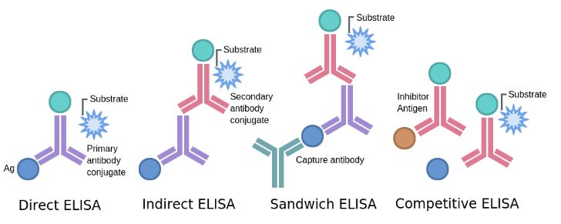**Types of ELISA**

**-Direct ELISA：**response to an antigen.

**-Indirect ELISA:** antibody concentration

**-Sandwich ELISA** Analyzing complex samples.

**-Competitive ELISA:** Detecting small antigens that cannot be bound by two different antibodies.

**-ELISA elements:** Plate/shaker/wash/stop solution/tetramethylbenzidine/control.

**ELISA troubleshooting:** High background/Low OD reading/Poor standard curve/No signa

**2Lateral flow assay**(No need for specialized equipment and answer in 30 minutes)l

**3Biosensor**

图示

**4Proton-ELISA:** develop/take advantage of biochemical reactions that release H+ (proton) so you can use a ISFET readout

**5 Electrochemical Sensors**:

**Nernst Equation**

Glucose + Gox-FAD Gluconolactone + Gox-FADH2

Gox-FADH2 + O2 Gox-FAD + H2O2

H2O2 2H+ + O2 + 2e-

**Hemophilia:** VIII (FVIII) and factor IX (FIX). (Factor IX is a blood clotting factor-activated by vitamin K.)

Types of ELISA